Commands & Setup Steps

### Installing the extension

Install the following extensions from the extension marketplace

* Python
* Jupyter
* Pylance
* Gitlens

### Setting up a virtual environment for your thesis

To set up a virtual environment, use the following command

#### python -m venv env

This command will download a script for the virtual environment named as ‘env’ inn your working directory.

Now to activate this virtual environment, use the command

.\env\Scripts\activate

In case this command does not run then enable script execution by using the command

Set-ExecutionPolicy -Scope Process -ExecutionPolicy Bypass

The virtual environment will start

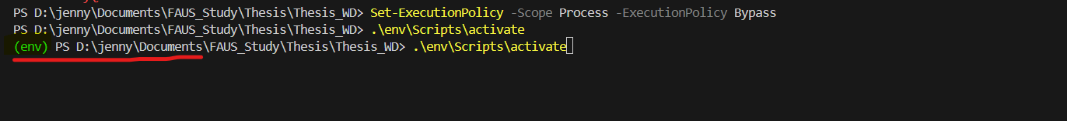

### Installing Jupyter notebook in Virtual Environment

To install jupyter notebook use the command:

##### pip install notebook

To launch notebook:

##### jupyter notebook

### Installing necessary libraries for simulator

The libraries you need are

* tensorflow
* tensorflow-federated
* jupyter
* pandas
* numpy
* scikit-learn
* matplotlib

The command to install all these libraries:

##### pip install tensorflow tensorflow-federated jupyter pandas numpy scikit-learn matplotlib

To setup the jupyter environment

1. Set the interpreter.  
   Open the Command Pallete using Shift+Ctrl+P and enter “**Python: Select Interpreter**” and press enter. Now it will show the interpreter presents select the one with the virtual environment supports.
2. Now open a jupyter file by going to File< new File<JupyterNotebook
3. Now select the kernal for your notebook.

In case the jupyter notebook throws any issue with kernal or interpreter  
1. **Your Virtual Environment Doesn’t Appear**:

* If your virtual environment is not listed under **Python: Select Interpreter**, try adding it manually:

*python -m ipykernel install --user --name=env --display-name "Python (env)"*

* Restart VS Code and repeat Step 2.

2. **Kernel Connection Errors**:

* Ensure notebook, ipykernel, and jupyter are installed in your virtual environment:

*pip install notebook ipykernel jupyter*